Justice In View: Student Guide
Immigration Research Hub

Table of Contents
Introduction 2
Survey Instrument 4
Court Locations 7
Safety and Commitment to Non-Intervention 7
Frequently Asked Questions 8
Glossary of Terms 10
Administrative Structure of Immigration Courts 12
Immigration Research Hub - Student Agreement 13
Suggested Reading List and Other Supplementary Materials 15
Student Fieldnote Guide 18
About the Authors 21

Introduction
Justice in View is a national research and teaching initiative that invites you into immigration court. You’ll be trained to conduct ethnographic observations in U.S. immigration courts—meaning you’ll learn how to carefully watch, document, and analyze what happens in real hearings. By observing proceedings firsthand, you’ll see how law, bureaucracy, and politics intersect in the day-to-day administration of immigration justice.
This project places students in immigration courtrooms across the United States to observe and record how justice is enacted—or denied—in real time. Immigration court is often opaque, politically charged, and deeply consequential. Court-watching helps make its everyday workings more visible. By learning immigration law basics, research ethics, and observational methods, you become part of a national network of student researchers generating rich, collective data about courtroom dynamics. This work helps democratize knowledge production while shedding light on the emotional, bureaucratic, and political forces shaping immigration adjudication today.
Participating in Justice in View supports your learning in three key areas:
- Legal socialization: You’ll develop a grounded understanding of how law operates in practice and how due process is enacted or constrained in real courtroom settings. Watching hearings firsthand shows you law as a lived, contested process shaped by power, discretion, and interpretation.
- Research skills: You’ll build practical training in qualitative and ethnographic methods. Through systematic observation, detailed fieldnote writing, and analysis, you’ll learn how to study institutional processes ethically and rigorously—skills that strengthen research papers, theses, and future fieldwork.
- Civic and ethical engagement: You’ll practice professionalism, empathy, and reflexivity while observing proceedings in politically charged public spaces. This experience deepens your awareness of justice, accountability, and the ethical responsibilities that come with doing scholarship in real-world settings.
Training Curriculum
Before you begin court observation, you’ll complete an asynchronous online training. Each module ends with a short quiz. When you finish, you’ll receive a downloadable certificate to confirm completion.
These materials are designed to prepare and support you as an observer. Modules cover immigration law basics, ethnographic techniques, and ethical considerations under authoritarian conditions. A fieldnote survey helps you to structure your observations and safety protocols prioritize well-being and mitigate risks. Our collective data-sharing model supports transparency and allows findings to inform research, advocacy, and public understanding. Using these materials responsibly means balancing rigor with care—for respondents coming before the court, for the research, and for yourselves.
Training is only the beginning. Faculty supervision and ongoing class/lab discussion are part of the experience. Regular reflection and collective analysis help ensure ethical engagement, strong data quality, and student well-being throughout the semester.

Nuts and Bolts
- Immigration court is, by default, open to the public. Judges can choose to close the court due to the sensitive nature of the proceedings. This is more likely to happen during “Merits Hearings” but can happen during “Master Calendar Hearings” as well. The guidance here is to leave without contestation if a judge requests it.
- Immigration court is generally open Monday through Friday, closed on Federal Holidays. It changes from court to court, but many judges have lighter dockets on Mondays and Fridays.
- Hearings typically start at 8/8:30 and 1/1:30 - it is recommended to be in the courthouse prior to the beginning of the hearing whenever possible.

Keep in Mind
- Court-watching alone can be exhausting, heartbreaking, and hard to sustain.
- Court-watching as part of a collective—even when you’re in different places—means you can debrief together, reflect together, and support each other.
- You can use these materials independently if you choose, but if you’re interested in observing immigration court, we strongly encourage you to connect with the Justice in View network so you can be part of a shared learning and research community.

Survey Instrument

The survey instrument is a structured observation form on Qualtrics that guides you through documenting courtroom dynamics, participant interactions, and procedural practices during immigration hearings. Designed to complement ethnographic fieldnotes, the survey ensures consistency across observations while allowing space for critical reflection.
The use of electronics is not allowed in the courtrooms. You should either hand write notes in a notebook of your choosing (we recommend hardbound notebooks for writing ease) or a pdf version of the Qualtrics form could be printed and filled out in the courtroom. If courses opt for the latter, you will still have to manually enter the information into the online instrument.
Depending on how many hearings you observe and how detailed your fieldnotes, the survey takes approximately 45-90 minutes. Upon completion of a survey, you will receive an emailed copy of your data that you can submit to your instructor. We invite you to use these materials for projects, presentations, or public-facing publications that advance transparency and understanding of the immigration court system. To do so, Institutional Reach Board (IRB) approval may be required. Please consult with your instructor.
Below is a QR code and link to the survey instrument, as well as a few sample screenshots of the survey. We invite you to visit the link, review Module 5: Courtwatching Survey & Data Collection.

https://csulb.qualtrics.com/jfe/form/SV_2uF3AbOgRWMmErc

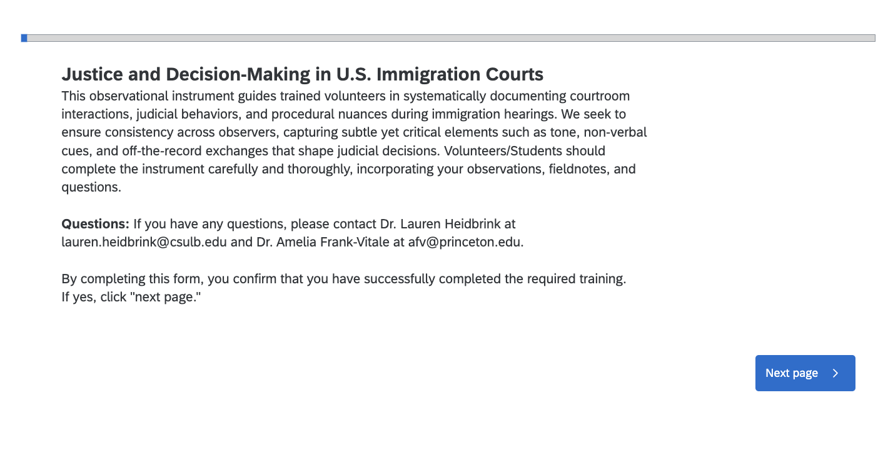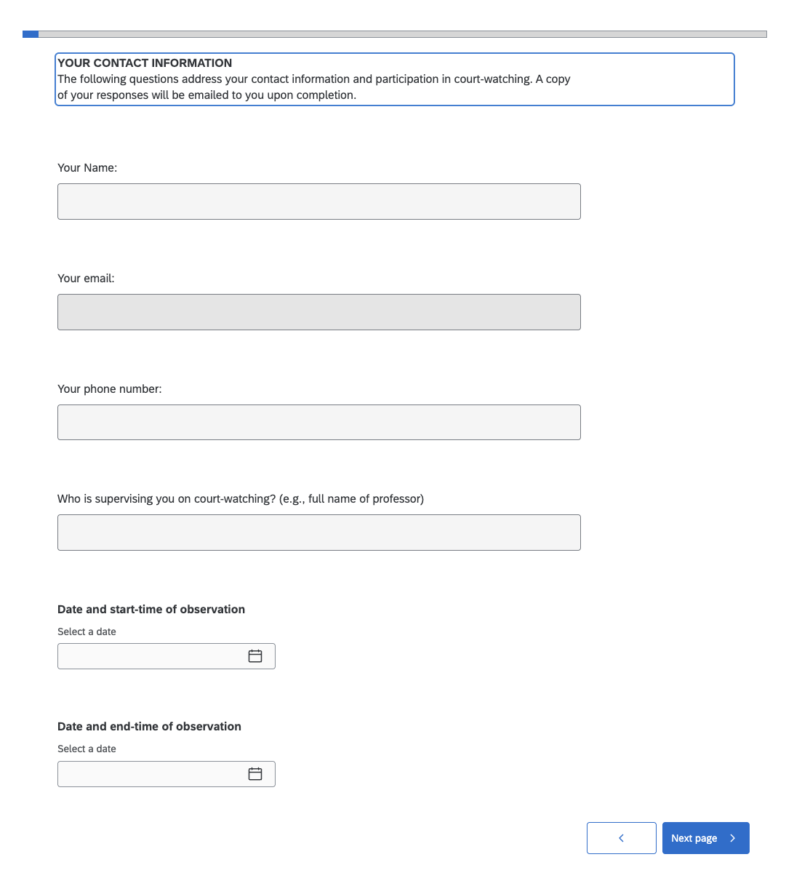
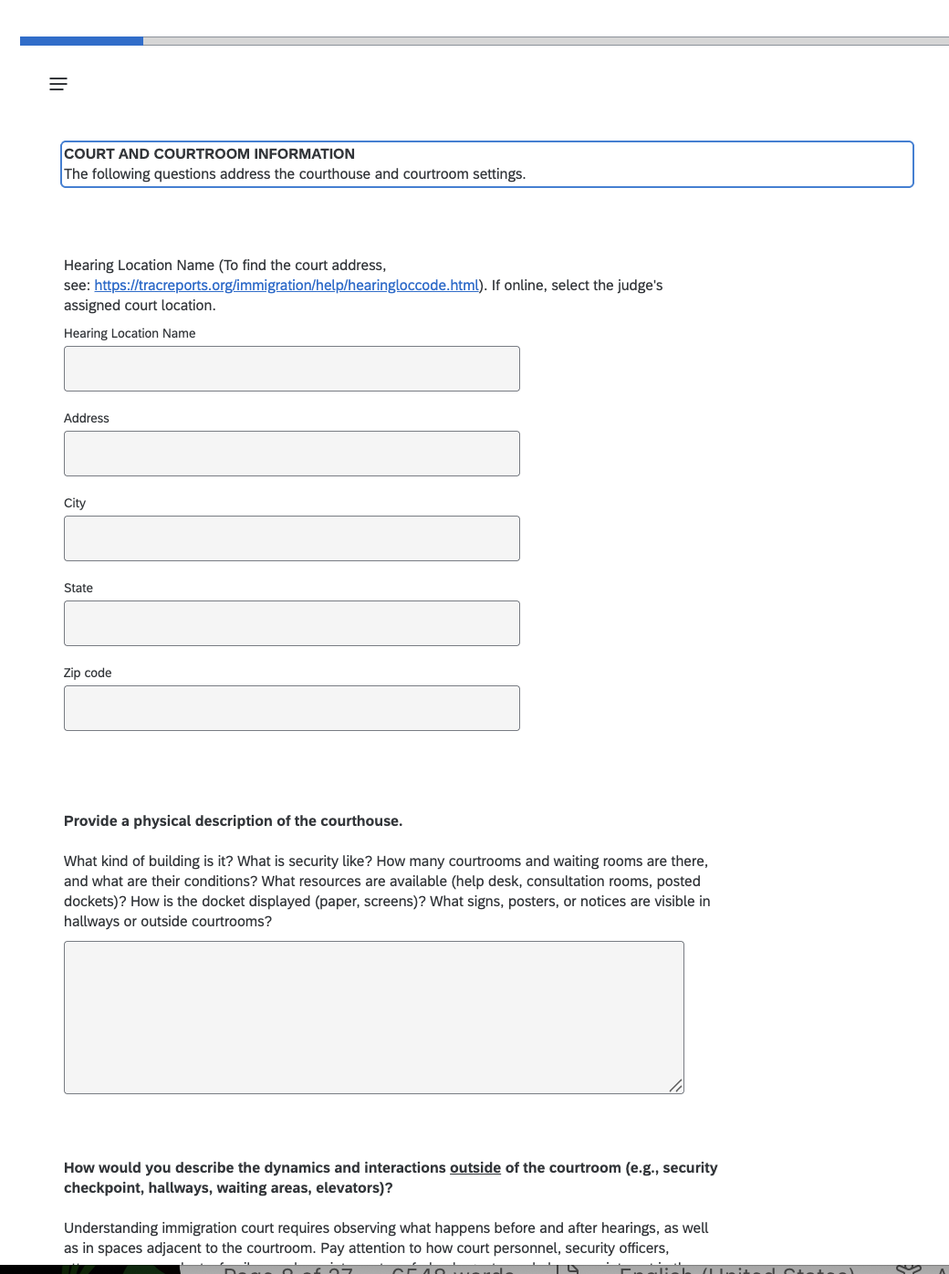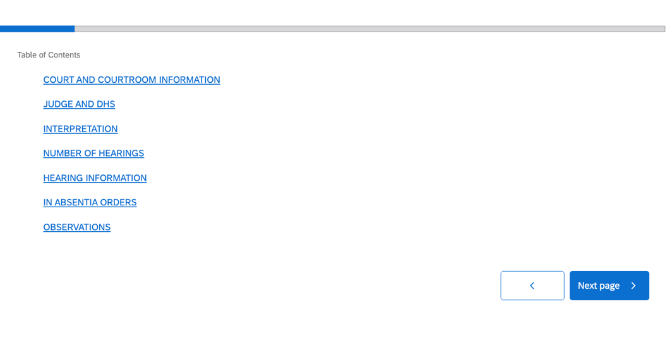

Court Locations
Immigration court is open to the public. Observers are not required to advise the court of their presence, but it is good practice to communicate with EOIR and let them know that you will be there.
To locate a court near you, go to the DOJ EOIR directory: https://www.justice.gov/eoir/find-immigration-court-and-access-internet-based-hearings

Click the hyperlink for your court of interest to view:
  - Street address and hours of operation
  - Court administrative roster
  - EOIR’s latest Guidelines for Observing in Immigration Court

Safety and Commitment to Non-Intervention
Before you enter the courtroom, it’s important to understand that safety and non-intervention are core principles of this project. Immigration courts operate in a highly politicized and increasingly anti-immigrant environment. You may see federal agents—uniformed, plain-clothed, and sometimes masked—in the courtroom, hallways, or waiting areas. Some may use phones or biometric tools to identify, track, or gather information about people present, including observers. For your safety (and to protect the integrity of the research), you should maintain a low profile and avoid anything that could be interpreted as interference.
It’s also important to recognize that immigration courts are shared spaces. You may encounter faith leaders accompanying families, community activists monitoring conditions, legal volunteers offering basic guidance, and people there to support loved ones. Many of these groups follow protocols that include supportive intervention or accompaniment. That work matters. But this project has a different purpose: we are conducting research-based, ethnographic observation. Your role is to watch, document, and analyze—not to intervene, correct injustices, or support respondents in the moment.
This can be emotionally difficult. You may witness unfairness, rushed decisions, or practices that feel profoundly wrong. The urge to help is human. But intervening can jeopardize someone’s case, put you at risk, and compromise the research. Students who do not follow non-intervention guidelines may be asked to leave by the court and could draw unwanted attention from federal agents. If you feel called to more direct support or activism, there are many pathways—community nonprofits, sanctuary groups, court-accompaniment teams, and legal aid organizations often welcome volunteers. Those engagements are important, but distinct from this project’s goals.
This project protects you by giving you a clear and safe role: observe, document, learn. Through disciplined witnessing, you contribute to transparency, public knowledge, and structural understanding—work that is especially essential in a moment of heightened enforcement and shrinking oversight.

Frequently Asked Questions

What should I bring to court?
Bring a government-issued ID, your observation form or notebook, a pen, sweater/jacket, water bottle, and snack for when the court is in recess. Do not bring cameras, laptops, or recording devices, as electronic recording is prohibited. You may bring your cell phone into the court building, but must turn it off when entering a courtroom. Dress professionally and avoid anything that might distract from the seriousness of the proceedings.
How should I introduce myself when entering court?
Upon entering the courtroom, quietly inform the clerk or judge that you are a university student participating in a class observation project. Speak respectfully, use a calm tone, and identify yourself as a court observer. Once acknowledged, take a seat quietly and begin observing.
What do I do if someone asks me for legal assistance?
Court observers must not provide legal advice or counsel under any circumstances, even if they are familiar with immigration law. If an individual requests assistance, you may offer general directions within the courthouse or read aloud information printed on official documents if requested. Politely refer the person to appropriate resources, such as the reception window or designated “pro bono room,” if it exists. Many courthouses also host nonprofit legal organizations (e.g., Catholic Charities, Esperanza, etc.) that can provide qualified legal guidance and support.

If a judge declines observation, what should I do?
Thank the judge courteously for their time and consideration. If appropriate, you may respectfully ask whether they know of any colleagues who might permit student observation or if there are other hearings during which observation would be possible. Maintain a professional and polite demeanor at all times.

How should I request permission to observe an individual hearing?
If the respondent is represented by an attorney, all communication must go through the attorney. Politely ask the attorney whether observation would be permissible; if they agree, the attorney will obtain consent from their client directly. To maintain ethical standards, limit your interaction with the respondent as much as possible and refrain from initiating direct communication. If the respondent is unrepresented, the judge (typically with the assistance of an interpreter) will ask the respondent on your behalf whether they consent to your observation of the hearing.

Can I take notes during hearings?
Yes, you may take written notes discreetly, using the observation guide provided. However, never record audio, video, or take photographs. Avoid including identifying information about respondents or witnesses in your notes to maintain confidentiality. Make sure, however, to note the name of the judge and DHS attorney(s) whenever possible.
What if a judge or attorney asks me to stop taking notes or leave the courtroom?
You must comply immediately and respectfully. Thank them for their time, exit the courtroom quietly, and document the event in your fieldnotes afterward. Notify your instructor so the incident can be reviewed for learning or follow-up. Documenting what we are precluded from observing and under what circumstances can be just as important in the long run.
What should I do if court observation feels overwhelming or if I witness something distressing?
It is natural to feel emotional or unsettled when observing difficult or traumatic proceedings. If you begin to feel overwhelmed, you may step outside briefly to collect yourself or take a short break. Engage in self-care strategies such as debriefing with peers or instructors, journaling, or reflecting privately after the session. Faculty supervisors are available to discuss your experience, help process emotional reactions, and connect you with campus wellness resources if needed. Participating in debriefing discussions is an important part of developing ethical awareness and reflexivity in this work.
Can students and instructors use the data collected?
Yes. Students and instructors receive copies of their observation data and may use it for course projects, conference presentations, or public-facing publications. All uses of data must maintain confidentiality of individuals and uphold research ethics.
Please note: If you wish to do additional research connected to this project, you must go through your institution’s IRBs to ensure compliance with research standards.

Glossary of Terms

A-number: | unique number assigned to non-citizens as form of identification
Administrative Closure | A docketing tool that temporarily pauses removal proceedings indefinitely while a case remains pending, often used when awaiting adjudication of benefits outside immigration court.
Asylum | A legal status sought by a noncitizen upon arrival in the United States, who claims to fear returning to their home country on account a of specific kind of persecution.
BIA | Board of Immigration Appeals; under EOIR, highest U.S administrative body for interpreting and applying immigration laws
Bond Hearing | A hearing to determine whether a detained individual should be released while their case is pending and under what conditions.
Cancellation of removal | a means of avoiding removal and obtaining permanent residence for people whose deportation would cause extreme and unusual hardship to a US citizen minor and who have been in the United States for at least 10 consecutive years
Continuance | A postponement of immigration court proceedings to a future date set by the immigration judge.
Convention Against Torture (CAT) | An international convention, signed by the US. Provides protection for individuals who can prove it is more likely than not they will be tortured if returned to their home country, available even when asylum is barred.
DHS | Department of Homeland Security
EOIR | Executive Office for Immigration Review; office with oversight over immigration courts and the BIA; Housed in the Department of Justice
EOIR-33/IC (Change of Address) | The form respondents must file within five working days of any address change while their case is pending.
ERO | Enforcement and Removal Operations
I-213 (Record of Deportable Status) | A form prepared by DHS that documents a person's arrest, immigration history, and the basis for removability charges.
I-485 (Register Permanent Residence / Adjust Status) | An application to adjust from another immigration status to become a lawful permanent resident while in the United States.
I-589 (Asylum and Withholding of Removal) | The application noncitizens must file to apply for asylum, withholding of removal, or protection under the Convention Against Torture.
I-601 (Waiver of Grounds of Inadmissibility) | An application to waive certain grounds that would otherwise make someone inadmissible to the United States.
I-765 (Employment Authorization) | An application for work authorization for non-citizens. Asylum applicants can file for this 180 days after applying for asylum.
I-862 (Notice to Appear) | The charging document that initiates removal proceedings against a noncitizen and lists the grounds of removability
ICE | Immigration and Customs Enforcement
IJ | Immigration Judge
In Absentia | A removal order issued by a judge for a noncitizen who did not appear for their hearing
INA | Immigration and Nationality Act; Law governing immigration and removal matters in the United States.
INA § 208 | The statute governing asylum eligibility, including the one-year filing deadline and grounds for denial.
INA § 212 (a) | Lists the grounds of inadmissibility that prevent noncitizens from entering or being admitted to the United States.
INA § 237 (a) | Lists the grounds of deportability for noncitizens who are already in or have been admitted to the United States
INA § 240 | Governs removal proceedings before immigration judges, including procedures and burdens of proof.
INA § 241(b)(3) | Provides for withholding of removal for individuals who can demonstrate they would more likely than not face persecution.
Master Calendar Hearing | Similar to an arraignment in criminal court; a hearing with many respondents where they are read their rights, the charges against them, and may be asked how they plead.
Merits Hearing | Hearing of an individual respondent where they present the merits of their claim to relief from removal in front of an Immigration Judge
NTA (Notice to Appear, I-862) | The charging document that initiates removal proceedings against a noncitizen and lists the grounds of removability
Off Calendar | A case status where the hearing is temporarily removed from the court's active calendar.
OPLA | Office of the Principal Legal Advisor; Office housing the attorneys who represent the Department of Homeland Security in immigration proceedings
Pretermit | Decide not to hear an asylum case based on a decision that the initial filings do not hold sufficient evidence
Prosecutorial Discretion | The authority of an agency or officer to decide what charges to bring and how to pursue each case. A law-enforcement officer who declines to pursue a case against a person has favorably exercised prosecutorial discretion
Respondent | Term used in immigration court to refer to the noncitizen in removal proceedings
Special Immigration Juvenile Status (SIJS) | Relief for undocumented children who have been abused, neglected, or abandoned by one or both parents and for whom it is not in their best interest to return to their home country.
TA | Trial Attorney: one of the titles used to refer to the attorneys representing the Department of Homeland Security
Temporary Protected Status (TPS) | A legal grant of permission for nationals of particular countries to temporarily remain in the U.S.
Violence Against Women Act (VAWA) | As a provision of this Act, there is an immigration component that allows relief for abused spouses, children, or parents of U.S. citizens or lawful permanent residents to self-petition for immigration status without the abuser's cooperation.
Voluntary Departure | An order given by an immigration judge to leave the country within a given period of time without being detained
WebEx | The online platform used by immigration courts
Withholding of Removal | A status granted to people who are barred from asylum but whose cases demonstrate the need for protection, can be granted under the INA or under CAT.

Administrative Structure of Immigration Courts

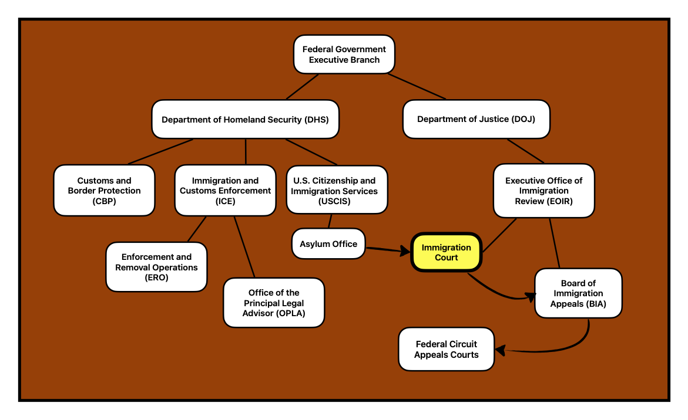

Immigration Research Hub - Student Agreement
Purpose and Opportunity
Justice in View offers students an opportunity to observe U.S. immigration courts and learn firsthand how law, bureaucracy, and advocacy intersect. As a court observer, you will contribute to a collective research and education project designed to better understand courtroom practices and promote transparency in immigration proceedings.
Acknowledgment and Time Commitment
Participation in this project is voluntary and largely independent. Students are expected to complete required training prior to observation and commit to approximately 20 hours of court observation and corresponding write-up.
Behavioral Expectations
As a court observer, you are representing both your university and the broader court-watching community. Your presence in court must always reflect professionalism, neutrality, and respect for all participants. We ask all students participating in this project to read carefully and sign this agreement. By signing below, you acknowledge and agree to the following expectations:

Training and Documentation
- I will complete all required training prior to attending court.
- I will transfer all notes and information to the designated online system within one week of each observation.

Courtroom Conduct
- I will maintain a quiet, respectful presence in the courtroom and follow all instructions from court staff, including requests to leave the courtroom or courthouse.
- I will turn off my phone and refrain from eating, drinking, or disrupting proceedings.
- I will not take photos, videos, or make audio recordings, as it violates federal law.

Neutrality and Non-Intervention
- I understand that my role is to observe only. I will not intervene in hearings or interact with judges, attorneys, or respondents unless directly addressed.
- I will not offer legal advice, advocacy, or assistance to individuals appearing in court or in the waiting areas.
- I will not discuss or attempt to influence the outcome of any case.
- I will refrain from any actions, speech, or gestures that could be perceived as confrontational or political.

Respect and Confidentiality
- I will respect the privacy of all individuals present and will not share identifying or personal information obtained during observations.
- Any notes or data I collect will be used solely for academic and research purposes in accordance with ethical research standards.

Safety and Nonviolence
- I understand that federal law enforcement officers may be present in or around the courthouse. I will remain calm, non-confrontational, and compliant with all security directives.
- I will practice self-care and communicate with faculty supervisors if I experience distress related to court observations.

Eligibility and Responsibility
- I am at least 18 years old.
- I understand that participation is voluntary, and I am responsible for my personal safety and decision to observe in person.
- I am either a U.S. citizen or, if not, I will pursue online observations when as available and consult an attorney prior to in-person participation.
- I am responsible for my own transportation and any related costs.
- I acknowledge that I am part of a national collective are participating in this project and that signing this agreement reflects my commitment to that collective.

Acknowledgment
By signing below, I confirm that I have read and understood the expectations outlined above. I agree to conduct myself in accordance with the principles of professionalism, nonviolence, and nonintervention, and to contribute responsibly to the goals of this educational project.

Name: ___________________________ Date: ____________________________
Signature: ________________________
Email: ___________________________ Phone: ___________________________

Supervising Faculty Member (if applicable): ___________________________
Supervising Faculty Member email (if applicable): ___________________________
Name of Institution: ___________________________

Suggested Reading List and Other Supplementary Materials

Research Articles
Abrego, L. (2021). Research as accompaniment: Reflections on objectivity, ethics, and emotions https://escholarship.org/content/qt34v2g837/qt34v2g837_noSplash_b851abbb14dd2d9f0613ce5de1f250cc.pdf?t=qjqeo1
Aiken, S., & Silverman, S. J. (2021). “Decarceral futures: Bridging immigration and prison justice towards an abolitionist future.” Citizenship Studies, 25(6), 737–757. https://doi.org/10.1080/13621025.2021.1890405.
Asad, Asad L. 2019. “Deportation Decisions: Judicial Decision-Making in an American Immigration Court.” American Behavioral Scientist 63 (9): 1221–49. https://doi.org/10.1177/0002764219835267.
Barak, M. P. (2021). “Can you hear me now? Attorney perceptions of interpretation, technology, and power in immigration court.” Journal on Migration and Human Security, 9(4), 207–223. https://doi.org/10.1177/23315024211034740
Bens, Jonas. “The Courtroom as an Affective Arrangement: Analysing Atmospheres in Courtroom Ethnography.” The Journal of Legal Pluralism and Unofficial Law 50, no. 3 (2018): 336–55. https://doi.org/10.1080/07329113.2018.1550313.
Benson, Lenni B., Decio Coviello, Nicola Perisco, and Petra E. Todd. “Legal Representation in Immigration Courts: The Impact of Randomly Assigned Observers.” July 8, 2025.
Benton, G. (2023, September 7). “Lost in AI translation: Growing reliance on language apps jeopardizes some asylum applications.” The Guardian. https://www.theguardian.com/us-news/2023/sep/07/asylum-seekers-ai-translation-apps
Boles, Matthew. “Language Access in Immigration Court: Guatemalan Indigenous Languages.” New Florida Journal of Anthropology 3, no. 2 (2022): 2. https://doi.org/10.32473/nfja.v3i2.129235.
Chan, Linus, Kimberly Horner, and Chris Levesque. “Process as Suffering: How U.S. Immigration Court Process and Culture Prevent Substantive Justice.” SSRN Scholarly Paper No. 4317101. Rochester, NY, December 28, 2022. https://doi.org/10.2139/ssrn.4317101.
Durham, Dory Mitros. “The Once and Future Judge: The Rise and Fall (and Rise) of Independence in U.S. Immigration Courts.” Notre Dame Law Review 81 (2006 2005): 655.
Eagly, I., & Shafer, S. (2021). “Measuring in absentia removal in immigration court.” University of Pennsylvania Law Review, 169(4), 935–984. https://scholarship.law.upenn.edu/cgi/viewcontent.cgi?article=9695&context=penn_law_review
Galemba, Rebecca B., Sarah B. Horton, and Kristin E. Yarris. “Teaching in Immigration Court: Engaged Anthropology, Student Supervision, and Ethical Challenges Involved in Observing Public Hearings of Asylum Claimants.” Practicing Anthropology 0, no. 0 (2024): 1–11. https://doi.org/10.1080/08884552.2024.2381776.
Gomez, Valeria. “Geography as Due Process in Immigration Court.” Wisconsin Law Review 2023 (2023): 1.
Hsin, Amy, and Sofya Aptekar. “The Violence of Asylum: The Case of Undocumented Chinese Migration to the United States.” Social Forces 100, no. 3 (2022): 1195–217. https://doi.org/10.1093/sf/soab032.

Jain, Amit. “Bureaucrats in Robes: Immigration Judges and the Trappings of Courts.” Georgetown Immigration Law Journal 33, no. 2 (2018): 261–326.
Kerwin, D., & Millet, E. (2023). “The U.S. immigration courts: Dumping ground for the nation’s systemic immigration failures—The causes, composition, and politically difficult solutions to the court backlog.” Journal on Migration and Human Security, 11(2), 1–25. https://doi.org/10.1177/23315024231175379
Levesque, C., Horner, K., & Chan, L. (2022). “Crimmigrating narratives: Examining third-party observations of U.S. detained immigration court.” Law & Social Inquiry, 47(4), 1082–1108. https://doi.org/10.1017/lsi.2021.64
Marks, Dana Leigh. Reflections on a 40-Year Career as an Immigration Lawyer and Judge. Center for Migration Studies of New York, 2019. https://doi.org/10.14240/cmsesy040819.
Musalo, Karen, Anna O. Law, Annie Daher, Katharine M. Donato, and Chelsea Meiners. “With Fear, Favor, and Flawed Analysis: Decision-Making in U.S. Immigration Courts.” Boston College Law Review 65, no. 8 (2024): 2743.
Ngai, Mae. 2025. “The End of Asylum.” The New York Review of Books, October 12. https://www.nybooks.com/online/2025/10/12/the-end-of-asylum/.
Obinna, Denise N. “‘Alone in a Crowd: Indigenous Migrants and Language Barriers in American Immigration.’” Race and Justice 13, no. 4 (2023): 488–505. https://doi.org/10.1177/21533687211006448.
Peleg, Talia, and Ruben Loyo. “Transforming Deportation Defense: Lessons Learned from the Nation’s First Public Defender Program for Detained Immigrants.” SSRN Scholarly Paper No. 3868387. Rochester, NY, April 16, 2019. https://papers.ssrn.com/abstract=3868387.
Preston, Julia. 2023. “The Real Origins of the Border Crisis: How a Broken Asylum System Warped American Immigration.” Foreign Affairs 102 (4): 156–71.
Rao, Sonya. “Linguistic Dimensions of the Crimmigration Regime: Language Ideological Working Conditions in US Immigration Court.” PoLAR: Political and Legal Anthropology Review, ahead of print, July 4, 2024. https://doi.org/10.1111/plar.12574.
Ryo, Emily, and Ian Peacock. “Represented but Unequal: The Contingent Effect of Legal Representation in Removal Proceedings.” Law & Society Review 55, no. 4 (2021): 634–56. https://doi.org/10.1111/lasr.12574.
Yarris, Kristin Elizabeth. “ICE Offices and Immigration Courts: Accompaniment in Zones of Illegality.” Human Organization 80, no. 3 (2021): 214–23. https://doi.org/10.17730/1938-3525-80.3.214.

Books
Barak, Maya Pagni. 2023. The Slow Violence of Immigration Court. NYU Press.
Castañeda, Michelle. 2023. Disappearing Rooms: The Hidden Theaters of Immigration Law. With Molly Crabapple. Duke University Press.
Cleaveland, Carol, and Michele Waslin. 2024. Private Violence: Latin American Women and the Struggle for Asylum. NYU Press.
Goodman, Adam. 2020. The Deportation Machine: America’s Long History of Expelling Immigrants. Princeton University Press.
McGuirk, Siobhán, and Adrienne Pine, eds. Asylum for Sale: Profit and Protest in the Migration Industry. PM Press, 2020.
Ramji-Nogales, Jaya, Andrew I. Schoenholtz, Philip G. Schrag, and Edward M. Kennedy. Refugee Roulette: Disparities in Asylum Adjudication and Proposals for Reform. NYU Press, 2011.
Salyer, J.C. 2020. Court of Injustice: Law without Recognition in U.S. Immigration. Stanford University Press.

Podcasts and Webinars
- This American Life, “The Hand that Rocks the Gavel”: https://www.thisamericanlife.org/868/the-hand-that-rocks-the-gavel
- Immigration Review, “Special Episode - Interview with former Appellate Immigration Judge (BIA) Andrea Saenz”: https://www.buzzsprout.com/1063330/episodes/17316955
- Migration Policy Institute, “U.S. Immigration Courts at a Crisis Point”: https://www.migrationpolicy.org/events/immigration-courts-crisis-point
- KJZZ (NPR) Radio, “Chasing asylum” (3 part series): https://www.kjzz.org/chasingasylum

Analysts, Journalists, and News Sources to Follow:
- Center for Gender and Refugee Studies: https://cgrs.uclawsf.edu/
- Justice Action Center, Litigation Tracker: https://cgrs.uclawsf.edu/
- Aaron Reichlin-Melnik, attorney: https://www.americanimmigrationcouncil.org/authors/aaron-reichlin-melnick/ https://x.com/ReichlinMelnick
- Dr. Austin Kocher, geographer: https://austinkocher.substack.com?utm_source=navbar&utm_medium=web
- TRAC Reports: https://tracreports.org/immigration/

Other Court Observation and Accompaniment Projects
Some students may want to do additional observation or accompaniment in court after learning about court through your class. There are many local courtwatch groups, and there are a few national projects that they can plug into if they wish to do so.

- Acacia, Witness for Justice: https://acaciajustice.org/witness-for-justice/
- National Immigration Project: https://nipnlg.org/work/resources/sample-immigration-court-watch-observation-form
- Clooney Foundation for Justice: https://cfj.org/trialwatch/resources/trialwatch-training/
- American Bar Association Immigration Court Observation Project: https://aba-coi-school.teachable.com/p/court-observation-project

Student Fieldnote Guide

Observers can use these prompts as a menu, not a checklist. In any given visit you will only be able to note some of these topics. Your task is to produce thick, honest description of what you see, hear, and feel.

Basic of Fieldnotes
- Date, time, and location: city, specific immigration court, courtroom number
- Type of hearing: master calendar, merits; detained or non-detained; in-person, WebEx, or hybrid
- Presence of participants: judge, DHS attorney, respondent’s attorney (if any), interpreter, security, federal agents, family members, other observers
- Observer’s position: where you are sitting and what you can and cannot see or hear
- Page numbering: continuous pagination and note if you or others leave/re-enter the room

Courthouse, Security, and Space
- Exterior of the building: formal, modest, intimidating, corporate, run-down
- Entry process: security screening, guard interactions, signage about rules, phones, or recording
- Layout and condition: waiting areas, hallways, restrooms, help desks, attorney consultation rooms
- Docket posting: paper lists, electronic screens, or absence of postings
- Law enforcement presence: uniformed or plain-clothed agents, activities such as standing, scrolling phones, interacting with people

Waiting Rooms, Hallways, and “In-Between” Spaces
- Composition of waiting areas: respondents, children, families, attorneys, interpreters, advocates, security, observers
- Movement patterns: rushing, wandering, standing still, clustering in groups
- Tone and atmosphere: tense, routine, supportive, chaotic, confused, hopeful, resigned; changes over time
- Interactions observed: Attorneys with clients; Security or agents with respondents; Family members and children; Court staff with the public: helpful, dismissive, rushed, patient
- Visible emotions and expressions: fear, frustration, relief, boredom; tears, pacing, silence, joking

Inside the Courtroom: Atmosphere & Interaction
- Overall tone: formal, rushed, casual, punitive, bureaucratic, compassionate
- Entry and exit patterns; seating arrangements and their impact on power dynamics
- Speaking roles: who speaks most, who remains silent
- Pace of hearings: rapid-fire, detailed, interrupted
- Notable moments: impatience, empathy, confusion, ambivalence from judge or DHS attorney
- Off-the-record exchanges: side conversations, jokes, sighs, complaints and their effect on mood

Judges
- Opening of sessions: reading rights, explaining procedures
- Communication style: voice, facial expressions, body language—neutral, stern, kind, sarcastic, distracted
- Direct engagement: speaking to respondents or attorneys
- Efforts to ensure understanding: explanations, questions, interpreter checks
- Indicators of neutrality or bias: differential treatment across cases, nationalities, or languages
- Handling of due process: time for counsel, evidence gathering, continuances, appeal rights

DHS Attorneys (OPLA/Government Lawyers)
- Preparedness: organized files, case familiarity, responsiveness to judge’s questions
- Tone and approach: respectful, aggressive, dismissive, cooperative
- Addressing others: use of titles, pronouns, politeness
- Body language: eye contact, posture, multitasking, signs of frustration or boredom
- Requests and justifications: terminations, in absentia orders, bond denials, expedited removal

Respondents’ Attorneys
- Presence or absence of counsel and judicial response
- Preparedness: knowledge of client’s story, documents, legal arguments
- Strategies: requesting time, bond, challenging notice, opposing DHS, coaching respondent
- Relationship with client: warm, rushed, transactional, collaborative
- Communication: language used, behaviors, explanations during or after hearings

Interpreters & Language
- Mode of interpretation: in-person, phone, video; single or relay interpretation
- Accuracy and completeness: full interpretation, summarization, or omissions
- Interpreter’s delivery: tone, volume, pace; responses to clarification requests
- Breakdowns in interpretation: technical issues, confusion, untranslated side conversations
- Impact of language ability: participation versus silence

Respondents & Families
- Visible characteristics of respondents: age, gender, presence of family members
- Physical demeanor and movement: confident, hesitant, confused, exhausted
- Emotional reactions: crying, shaking, nervous laughter, silence
- Indicators of comprehension or confusion during proceedings
- Presence and behavior of children in court: seating, activities, adult responses
- Notable moments of dignity, resistance, humor, or solidarity

Politics, Bureaucracy, and Technology
- References to policies, presidential directives, or political debates
- Signs of bureaucratic pressure: rushed hearings, large dockets, time constraints, push for case clearance
- Use of technology: WebEx hearings, digital files, automated docket screens, biometrics, phone use by federal agents
- Presence and behavior of masked or plain-clothed agents: positioning, activities, interactions
- Impact of these elements on courtroom atmosphere: fear, surveillance, confusion

Your Positionality, Safety, and Emotional Responses
- Observer’s identity and its influence on perception: race, language, citizenship, class, gender, family immigration history
- Reactions of others to the observer: curiosity, suspicion, indifference, welcome
- Experiences of discomfort or anxiety and coping strategies: stepping out, grounding, peer check-ins
- Urges to intervene and adherence to non-intervention commitment
- Ethical and power-related questions arising from the act of witnessing

Evaluating and Deepening Your Notes
- Are your notes clear, dated, and detailed enough for someone to visualize the courtroom?
- Do they include both description (what happened) and reflection (your thoughts and feelings)?
- Which observations were most striking or significant?
- What patterns are emerging across hearings, judges, or courts?
- What remains unclear—legal terms, procedures, jokes, side conversations—and how might you learn more?
- Do you include your positionality and subjective reactions as an observer? What assumptions do you bring to the fieldsite?
- What further data or information is needed to confirm or complicate your interpretations?

About the Authors

Amelia Frank-Vitale, PhD: afv@princeton.edu
Amelia Frank-Vitale, PhD is an Assistant Professor of Anthropology and International Affairs at Princeton University. An anthropologist of migration and violence in Central America and Mexico, Dr. Frank-Vitale has documented the dangers facing people migrating across Mexico and the strategies they develop – including coming together in caravans – to manage those risks and defy restrictions on movement. Her book, Leave If You Can: Migration and Violence in Bordered Worlds, examines how Honduran youth navigate life after deportation, illuminating the changing nature of deportation as a consequence of the externalization of borders and connecting regimes of mobility control - and the creative ways people challenge them - across scale and space.

Drawing from this research, Dr. Frank-Vitale has served as an expert witness on country conditions in Honduras in asylum hearings. From there, she has built courses around interacting with immigration courts and asylum law, including piloting a Court Watching class for Barnard College’s Human Rights Program. She is co-founder and editor of Pressing Issues in Latin America.

Lauren Heidbrink PhD: lauren.heidbrink@csulb.edu
Lauren Heidbrink PhD is a Professor in the Department of Human Development at California State University, Long Beach. She is cultural anthropologist who focuses on the anthropology of childhood and migration in Central America. Her research and teaching interests include childhood and youth, transnational migration, performance and identity, engaged methodologies, and Central America. Her first book, Migrant Youth, Transnational Families, and the State: Care and Contested Interests (University of Pennsylvania Press, 2014), examines the experiences of migrant children in U.S. federal facilities for unaccompanied children and following release. With support of the National Science Foundation and the American Council of Learned Societies, her recent manuscript Migranthood: Youth in a New Era of Deportation (Stanford University Press, 2020) traces the impacts of the securitization of development on Indigenous Guatemalan youth following deportation from the U.S. and Mexico.

Dr. Heidbrink is co-founder and editor of Youth Circulations, a nexus for research, art and activism dedicated to examining the real and imagined circulations of global youth. She is co-founder and editor of Pressing Issues in Latin America. She serves on the Editorial Board for NYU Press’ Critical Perspectives on Youth Series, as Board President of Colectivo Vida Digna-Guatemala, and on the steering committee for Anthropologist Action Network for Immigrants and Refugees. She frequently serves as a country conditions expert in U.S. immigration proceedings.

Luis Guaman is an undergraduate student in the department of Political Science at Princeton He is interested in examining the political implications of the Latine experience in the United States. He approaches this from an interdisciplinary, mixed-methodology perspective, examining federal institutions and political behavior through immigration courtroom observations and experimental survey studies. He is currently applying for doctoral programs in Political Science, aspiring to become a professor that pursues rigorous interdisciplinary scholarship and mentors the next generation of academics.

